Neal Dawson-Elli HW3  
1)  
> **restart:**

**eq1:=diff(u(x,t),t)=diff(diff(u(x,t),x),x);**



> **N:=20;**

**y:=(2*n-1)/2*Pi;**

**An:=int((1-Ceq)*cos(y*x),x=0..1)/int(cos(y*x)^2,x=0..1);**

**C:=Ceq+sum(An*cos(y*x)*exp(-y^2*t),n=1..N):**

**dC:=diff(C,x):**







>

> **Pi;**



> **c_1:=subs(x=0.,C):**

> **#################### varying Cea vs concentration ################**

**with(plots):**

> **p1:=plot(subs(Ceq=0.01,c_1),t=0..5):**

**p2:=plot(subs(Ceq=0.25,c_1),t=0..5):**

**p3:=plot(subs(Ceq=0.50,c_1),t=0..5):**

**p4:=plot(subs(Ceq=0.75,c_1),t=0..5):**

**display(p1,p2,p3,p4);**

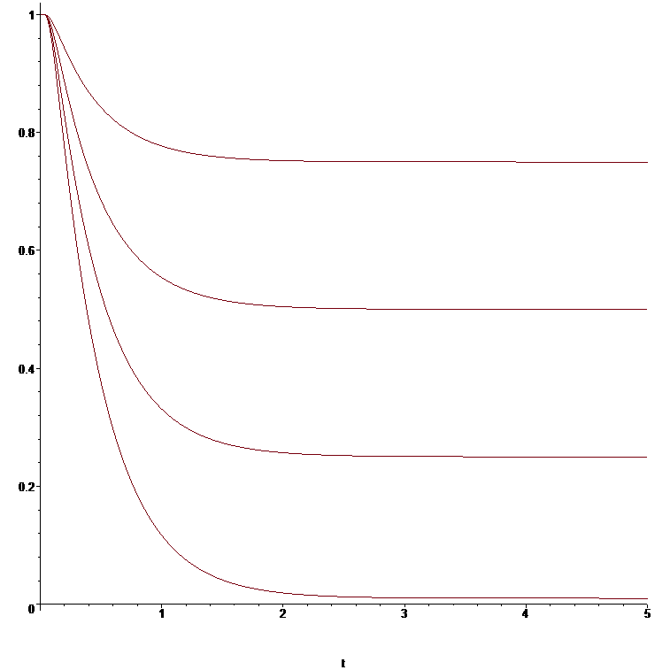

>

> **############## long times, varying Ceq ###############**

**with(plots):**

**m:=1;F:=96485;D1:=1e-12;L:=100e-6;ci:=1000;**

**ibatt:=subs(x=1,-m*F*D1*ci/L*dC):**

**p11:=plot(subs([Ceq=0.01,t=D1/L^2*T],ibatt),T=0..500):**

**p12:=plot(subs([Ceq=0.25,t=D1/L^2*T],ibatt),T=0..500):**

**p13:=plot(subs([Ceq=0.50,t=D1/L^2*T],ibatt),T=0..500):**

**p14:=plot(subs([Ceq=0.75,t=D1/L^2*T],ibatt),T=0..500):**

**display(p11,p12,p13,p14);**











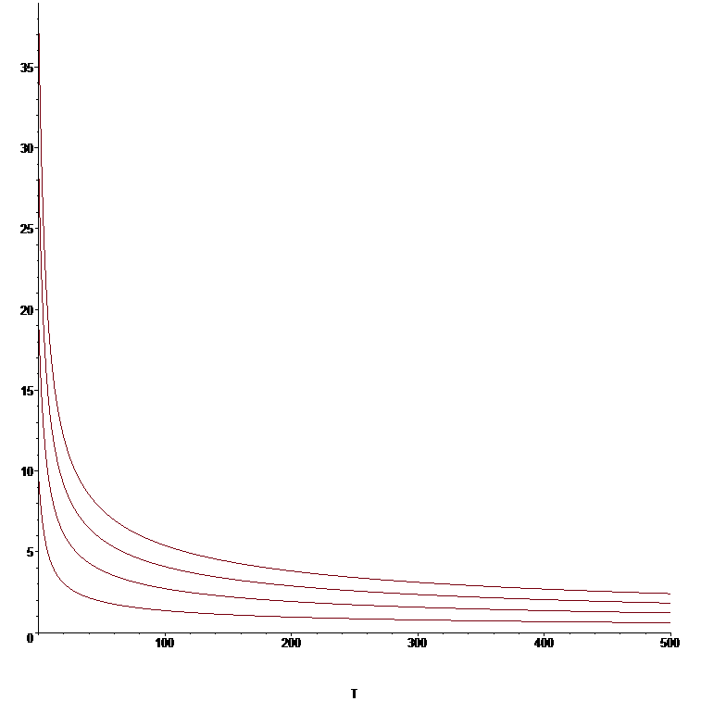

> **############# long times, varying L #############**

**with(plots):**

**m:=1;F:=96485;D1:=1e-12;L:=100e-6;ci:=1000;**

**ibatt:=subs(x=1,-m*F*D1*ci/L*dC):**

**p21:=plot(subs([Ceq=0.25,t=D1/L^2*T],ibatt),T=0..700):**

**L:=50e-6;ibatt:=subs(x=1,-m*F*D1*ci/L*dC):**

**p22:=plot(subs([Ceq=0.25,t=D1/L^2*T],ibatt),T=0..700):**

**L:=25e-6;ibatt:=subs(x=1,-m*F*D1*ci/L*dC):**

**p23:=plot(subs([Ceq=0.25,t=D1/L^2*T],ibatt),T=0..700):**

**L:=10e-6;ibatt:=subs(x=1,-m*F*D1*ci/L*dC):**

**p24:=plot(subs([Ceq=0.25,t=D1/L^2*T],ibatt),T=0..700):**

**display(p21,p22,p23,p24);**

















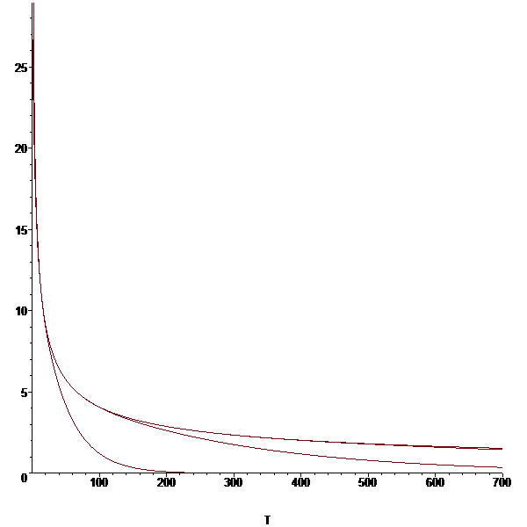

> **##################### varying L, short times ################**

**with(plots):**

**m:=1;F:=96485;D1:=1e-12;L:=100e-6;ci:=1000;**

**ibatt:=subs(x=1,-m*F*D1*ci/L*dC):**

**p21:=plot(subs([Ceq=0.5,t=D1/L^2*T],ibatt),T=0..0.01):**

**L:=50e-6;ibatt:=subs(x=1,-m*F*D1*ci/L*dC):**

**p22:=plot(subs([Ceq=0.5,t=D1/L^2*T],ibatt),T=0..0.01):**

**L:=25e-6;ibatt:=subs(x=1,-m*F*D1*ci/L*dC):**

**p23:=plot(subs([Ceq=0.5,t=D1/L^2*T],ibatt),T=0..0.01):**

**L:=10e-6;ibatt:=subs(x=1,-m*F*D1*ci/L*dC):**

**p24:=plot(subs([Ceq=0.5,t=D1/L^2*T],ibatt),T=0..0.01):**

**display(p21,p22,p23,p24);**

















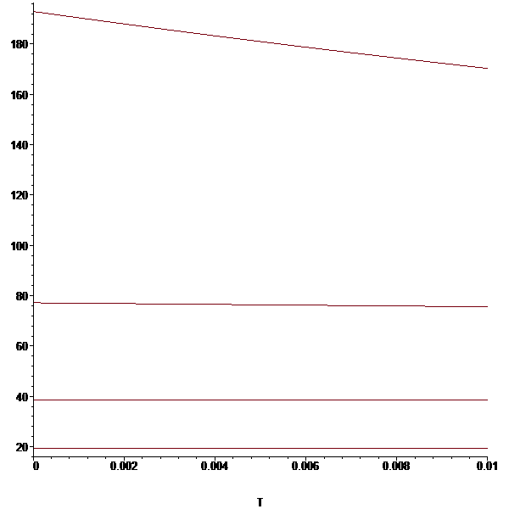

> **##################### varying D, long time ################**

**with(plots):**

**m:=1;F:=96485;D1:=1e-12;L:=100e-6;ci:=1000;**

**ibatt:=subs(x=1,-m*F*D1*ci/L*dC):**

**p41:=plot(subs([Ceq=0.5,t=D1/L^2*T],ibatt),T=0..700):**

**D1:=1e-11;ibatt:=subs(x=1,-m*F*D1*ci/L*dC):**

**p42:=plot(subs([Ceq=0.5,t=D1/L^2*T],ibatt),T=0..700):**

**D1:=1e-13;ibatt:=subs(x=1,-m*F*D1*ci/L*dC):**

**p43:=plot(subs([Ceq=0.5,t=D1/L^2*T],ibatt),T=0..700):**

**D1:=1e-14;ibatt:=subs(x=1,-m*F*D1*ci/L*dC):**

**p44:=plot(subs([Ceq=0.5,t=D1/L^2*T],ibatt),T=0..700):**

**display(p41,p42,p43,p44);**

















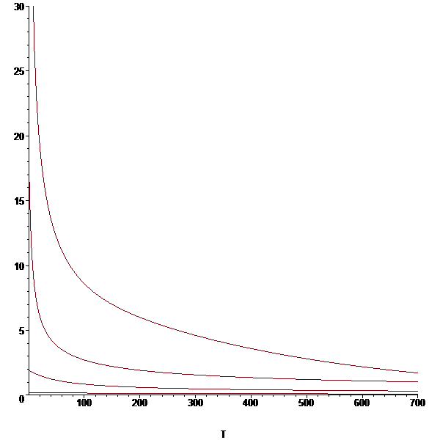

> **##################### varying ci, long time ################**

**with(plots):**

**m:=1;F:=96485;D1:=1e-12;L:=100e-6;ci:=1000;**

**ibatt:=subs(x=1,-m*F*D1*ci/L*dC):**

**p41:=plot(subs([Ceq=0.5,t=D1/L^2*T],ibatt),T=0..700):**

**ci:=2000;ibatt:=subs(x=1,-m*F*D1*ci/L*dC):**

**p42:=plot(subs([Ceq=0.5,t=D1/L^2*T],ibatt),T=0..700):**

**ci:=500;ibatt:=subs(x=1,-m*F*D1*ci/L*dC):**

**p43:=plot(subs([Ceq=0.5,t=D1/L^2*T],ibatt),T=0..700):**

**ci:=250;ibatt:=subs(x=1,-m*F*D1*ci/L*dC):**

**p44:=plot(subs([Ceq=0.5,t=D1/L^2*T],ibatt),T=0..700):**

**display(p41,p42,p43,p44);**

















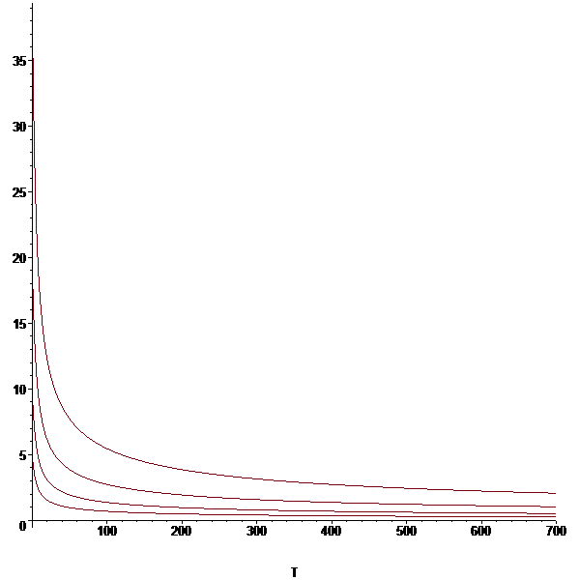

> **SOC:=int(C,x=0..1):**

**p1:=plot(subs(Ceq=0.01,SOC),t=0..1):**

**p2:=plot(subs(Ceq=0.25,SOC),t=0..1):**

**p3:=plot(subs(Ceq=0.50,SOC),t=0..1):**

**p4:=plot(subs(Ceq=0.75,SOC),t=0..1):**

**display(p1,p2,p3,p4);**

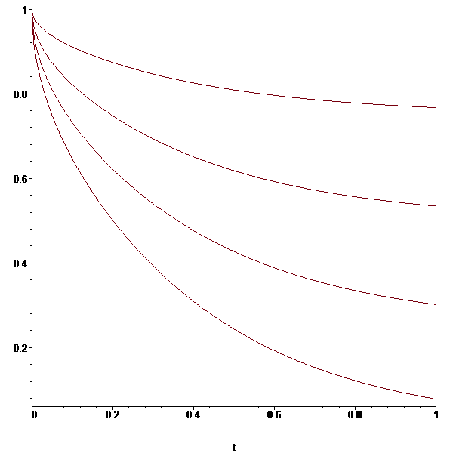

>

> **restart:**

**################ P2 ##################**

**eq1:=diff(u(x,t),t)=diff(diff(u(x,t),x),x);**



> **N:=20;**

**y:=(2*n-1)*Pi/2;**

**An:=int((0-Ceq)*cos(y*X),X=0..1)/int((cos(y*X))^2,X=0..1);**

**C:=Ceq+sum(An*cos(y*x)*exp(-y^2*t),n=1..N):**

**dC:=diff(C,x):**







>

> **Pi;**



>

> **#################### varying Cea vs concentration ################**

**with(plots):**

**c_1:=subs(x=0.,C):**

> **p1:=plot(subs(Ceq=0.01,c_1),t=0..5):**

**p2:=plot(subs(Ceq=0.25,c_1),t=0..5):**

**p3:=plot(subs(Ceq=0.50,c_1),t=0..5):**

**p4:=plot(subs(Ceq=0.75,c_1),t=0..5):**

**display(p1,p2,p3,p4);**

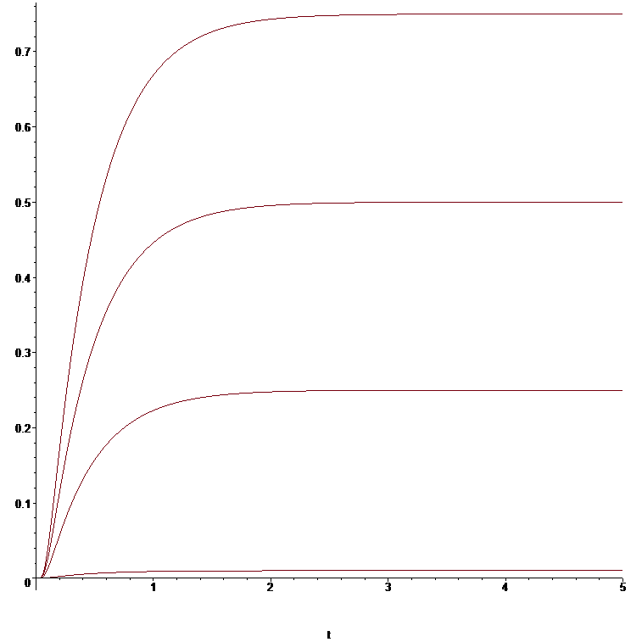

>

> **############## long times, varying Ceq ###############**

**with(plots):**

**m:=1;F:=96485;D1:=1e-12;L:=100e-6;ci:=1000;**

**ibatt:=subs(x=1,-m*F*D1*ci/L*dC):**

**p11:=plot(subs([Ceq=0.01,t=D1/L^2*T],ibatt),T=0..500):**

**p12:=plot(subs([Ceq=0.25,t=D1/L^2*T],ibatt),T=0..500):**

**p13:=plot(subs([Ceq=0.50,t=D1/L^2*T],ibatt),T=0..500):**

**p14:=plot(subs([Ceq=0.75,t=D1/L^2*T],ibatt),T=0..500):**

**display(p11,p12,p13,p14);**











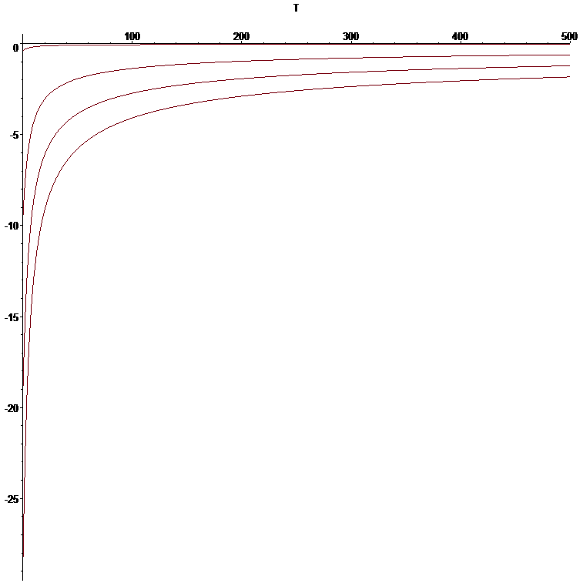

> **############# long times, varying L #############**

**with(plots):**

**m:=1;F:=96485;D1:=1e-12;L:=100e-6;ci:=1000;**

**ibatt:=subs(x=1,-m*F*D1*ci/L*dC):**

**p21:=plot(subs([Ceq=0.25,t=D1/L^2*T],ibatt),T=0..700):**

**L:=50e-6;ibatt:=subs(x=1,-m*F*D1*ci/L*dC):**

**p22:=plot(subs([Ceq=0.25,t=D1/L^2*T],ibatt),T=0..700):**

**L:=25e-6;ibatt:=subs(x=1,-m*F*D1*ci/L*dC):**

**p23:=plot(subs([Ceq=0.25,t=D1/L^2*T],ibatt),T=0..700):**

**L:=10e-6;ibatt:=subs(x=1,-m*F*D1*ci/L*dC):**

**p24:=plot(subs([Ceq=0.25,t=D1/L^2*T],ibatt),T=0..700):**

**display(p21,p22,p23,p24);**

















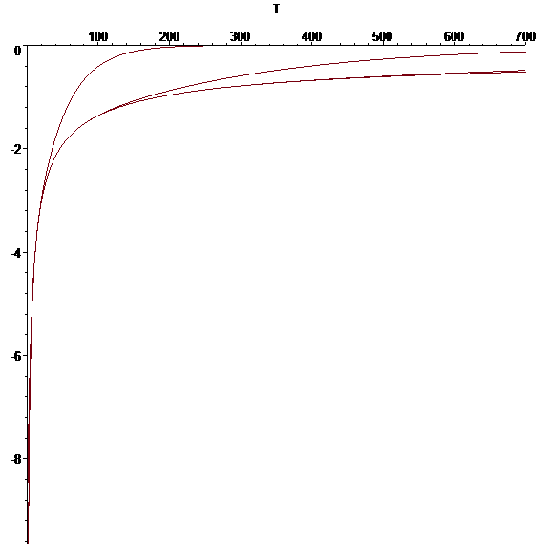

> **##################### varying L, short times ################**

**with(plots):**

**m:=1;F:=96485;D1:=1e-12;L:=100e-6;ci:=1000;**

**ibatt:=subs(x=1,-m*F*D1*ci/L*dC):**

**p21:=plot(subs([Ceq=0.5,t=D1/L^2*T],ibatt),T=0..0.01):**

**L:=50e-6;ibatt:=subs(x=1,-m*F*D1*ci/L*dC):**

**p22:=plot(subs([Ceq=0.5,t=D1/L^2*T],ibatt),T=0..0.01):**

**L:=25e-6;ibatt:=subs(x=1,-m*F*D1*ci/L*dC):**

**p23:=plot(subs([Ceq=0.5,t=D1/L^2*T],ibatt),T=0..0.01):**

**L:=10e-6;ibatt:=subs(x=1,-m*F*D1*ci/L*dC):**

**p24:=plot(subs([Ceq=0.5,t=D1/L^2*T],ibatt),T=0..0.01):**

**display(p21,p22,p23,p24);**

















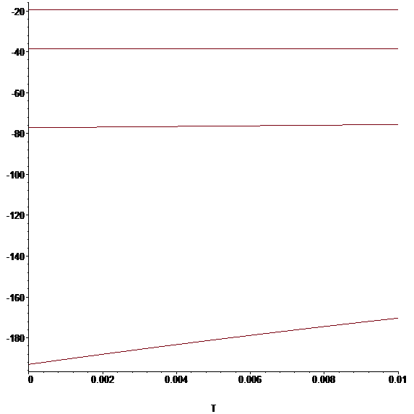

> **##################### varying D, long time ################**

**with(plots):**

**m:=1;F:=96485;D1:=1e-12;L:=100e-6;ci:=1000;**

**ibatt:=subs(x=1,-m*F*D1*ci/L*dC):**

**p41:=plot(subs([Ceq=0.5,t=D1/L^2*T],ibatt),T=0..700):**

**D1:=1e-11;ibatt:=subs(x=1,-m*F*D1*ci/L*dC):**

**p42:=plot(subs([Ceq=0.5,t=D1/L^2*T],ibatt),T=0..700):**

**D1:=1e-13;ibatt:=subs(x=1,-m*F*D1*ci/L*dC):**

**p43:=plot(subs([Ceq=0.5,t=D1/L^2*T],ibatt),T=0..700):**

**D1:=1e-14;ibatt:=subs(x=1,-m*F*D1*ci/L*dC):**

**p44:=plot(subs([Ceq=0.5,t=D1/L^2*T],ibatt),T=0..700):**

**display(p41,p42,p43,p44);**

















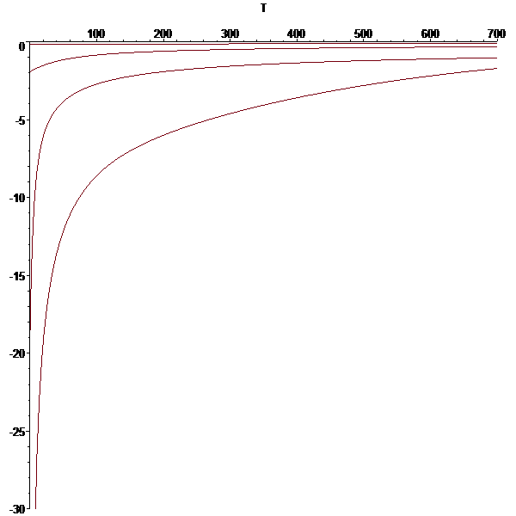

> **##################### varying ci, long time ################**

**with(plots):**

**m:=1;F:=96485;D1:=1e-12;L:=100e-6;ci:=1000;**

**ibatt:=subs(x=1,-m*F*D1*ci/L*dC):**

**p41:=plot(subs([Ceq=0.5,t=D1/L^2*T],ibatt),T=0..700):**

**ci:=2000;ibatt:=subs(x=1,-m*F*D1*ci/L*dC):**

**p42:=plot(subs([Ceq=0.5,t=D1/L^2*T],ibatt),T=0..700):**

**ci:=500;ibatt:=subs(x=1,-m*F*D1*ci/L*dC):**

**p43:=plot(subs([Ceq=0.5,t=D1/L^2*T],ibatt),T=0..700):**

**ci:=250;ibatt:=subs(x=1,-m*F*D1*ci/L*dC):**

**p44:=plot(subs([Ceq=0.5,t=D1/L^2*T],ibatt),T=0..700):**

**display(p41,p42,p43,p44);**

















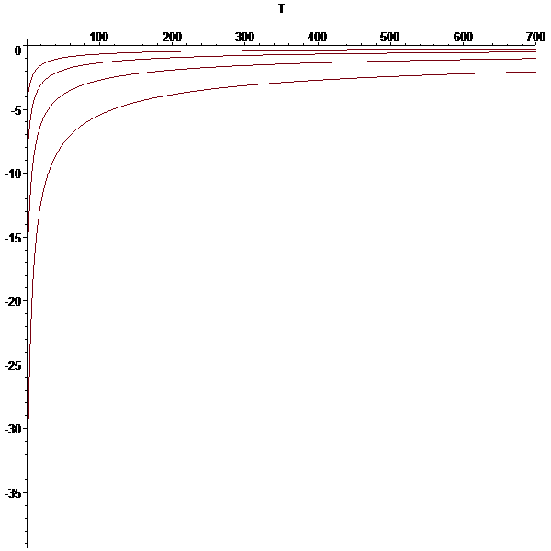

> **SOC:=int(C,x=0..1):**

**p1:=plot(subs(Ceq=0.01,SOC),t=0..1):**

**p2:=plot(subs(Ceq=0.25,SOC),t=0..1):**

**p3:=plot(subs(Ceq=0.50,SOC),t=0..1):**

**p4:=plot(subs(Ceq=0.75,SOC),t=0..1):**

**display(p1,p2,p3,p4);**

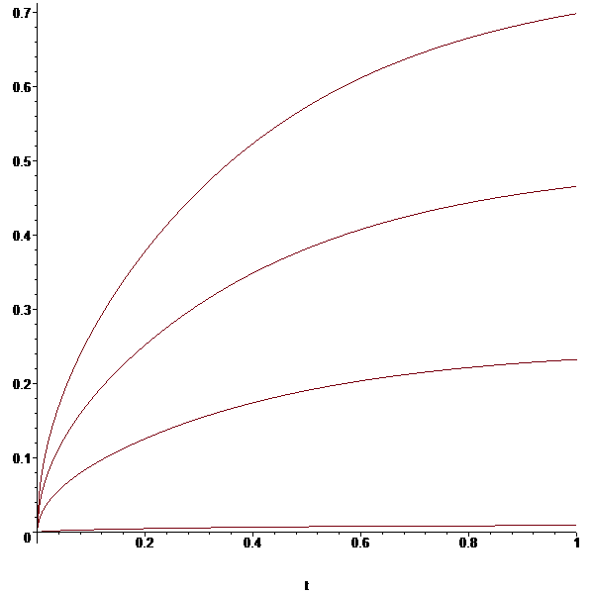

>

>

>

>

> **############## P3.1 ##############**

**restart:**

> **Digits:=15;**



> **N:=10;**



> **eq[0]:=u[0](t)=0;**



> **h:=1/(N+1):**

> **for i from 1 to N do eq[i]:=diff(u[i](t),t)=(u[i-1](t)-2*u[i](t)+u[i+1](t))/h^2;od;**





















> **eq[N+1]:=u[N+1](t)=0;**



> **ics:=seq(u[i](0)=1,i=0..N+1);**



> **Eqs:=seq(eq[i],i=0..N+1);**



> **infolevel[all]:=0;**



> **sol:=dsolve({Eqs,ics},type=numeric,stiff=true):**

> **infolevel[all]:=0;**

**sol(1);**





> **with(plots):**

> **odeplot(sol,[t,u[2](t)],0..1);**

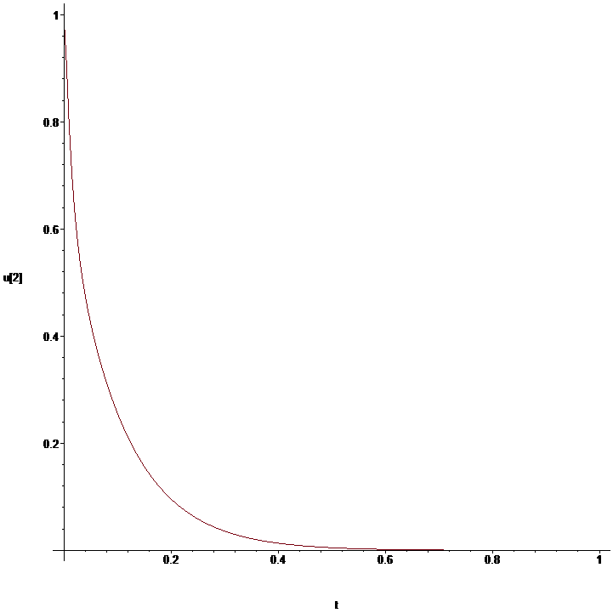

> **restart:**

**Digits:=15;**

**N:=10;**

**h:=1/N;**

**eq[0]:=u[1](t)-u[0](t)=0;**

**for i from 1 to N do eq[i]:=diff(u[i](t),t)=(u[i-1](t)-2*u[i](t)+u[i+1](t))/h^2;od;**

**eq[N+1]:=(u[N+1](t)-u[N](t))/h=-1;**

**ics:=seq(u[i](0)=1,i=0..N+1);**

**Eqs:=seq(eq[i],i=0..N+1);**

**sol:=dsolve({Eqs,ics},type=numeric,stiff=true):**

**with(plots):**

**odeplot(sol,[t,u[2](t)],0..1);**



































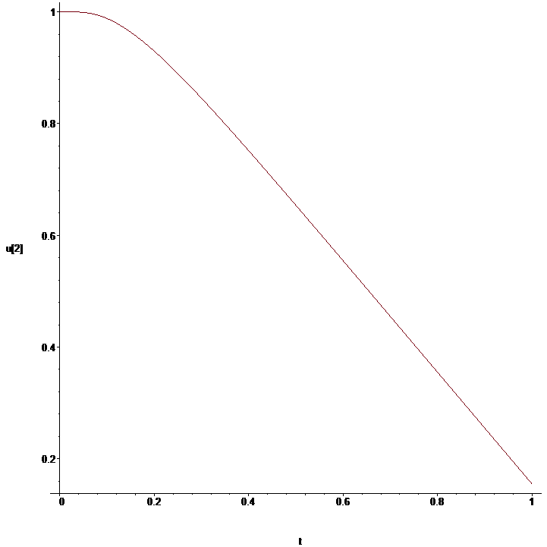

> **restart:**

**Digits:=15;**

**N:=10;**

**h:=1/N;**

**eq[0]:=u[1](t)-u[0](t)=0;# u0**

**for i from 1 to N do eq[i]:=diff(u[i](t),t)=(u[i-1](t)-2*u[i](t)+u[i+1](t))/h^2+2/(i*h)*(u[i+1](t)-u[i-1](t))/(2*h)-u[i](t)^2;od; #eqn**

**eq[N+1]:=(u[N+1](t)-u[N](t))/h=-1; #uN+1**

**ics:=seq(u[i](0)=1,i=0..N+1);**

**Eqs:=seq(eq[i],i=0..N+1);**

**sol:=dsolve({Eqs,ics},type=numeric,stiff=true):**

**with(plots):**

**odeplot(sol,[t,u[2](t)],0..1);**





































